Q1. 1D Convolution Using Constant Memory
Implement a program in CUDA to improve the performance of 1D parallel convolution using constant memory.

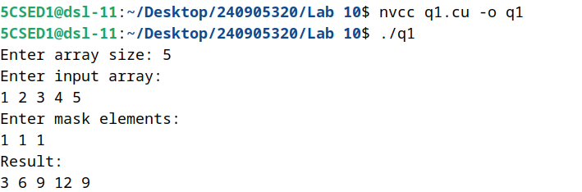

Q2. Tiled 1D Convolution
Implement a program in CUDA to perform tiled 1D convolution operation on the input array N of size width using the mask array M of size mask_width, to produce the resultant array P of size width.

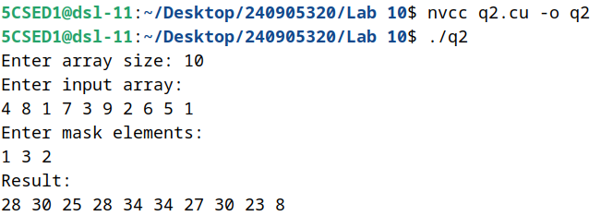
Q3. Matrix Multiplication Using 2D Grid and 2D Block
Implement a program in CUDA to perform matrix multiplication using 2D Grid of 2D Block.

